Golf Cart Rental Reservation Form
2 AND 4 PERSON MODELS AVAILABLE - (While supplies last!)
PRICE
$80 for 1 day, $150 for 2 days and $195 for 3 days
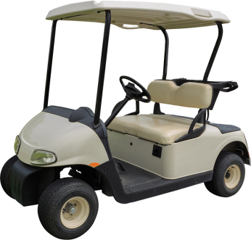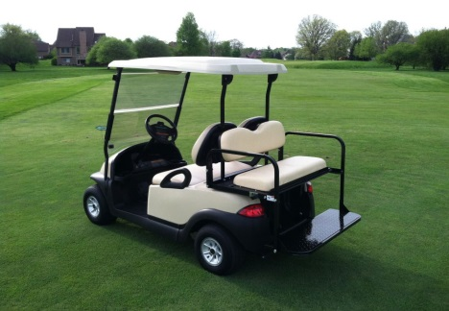
2 Person Cart (One Seat) 4 Person Cart (Two Seats)
Complete the reservation request below.
----------------------------------------------------------------------------------------------------------------------------------------------------------------
Type of Cart Requested: TWO PERSON __________ FOUR PERSON __________
Days Requested FRIDAY _______ SATURDAY _______ SUNDAY ________
Name: _____________________________________________________________
Address: ____________________________________________________________
City: _____________________________ State: ________________ Zip Code: ___________________
Phone Number: _____________________________ Email Address: ______________________________________
- No Operation within buildings or within the pavilion
- Only Licensed Drivers may operate Golf Carts
- In case of willful or flagrant violation of the rules of the Upper Midwest A-C Club™, as determined by Security or any Director, the vehicle will be impounded without a refund.
To complete your reservation, please fill out the form and return it with a check made payable to “Upper Midwest A-C Club™”. (Reservations with payment are taken in the order they are received. Reservations without payment are held on a “stand-by” basis.):
By mail:
Upper Midwest A-C Club™
c/o Lori Miller
13615 Hartungs Oaks Rd
Cologne, MN 55322
Please contact Lori Miller at 612-483-2712 or by email miller8120@gmail.com with any questions.
** Please remember to complete the TYPE OF CART and DAYS REQUESTED.

